Institute of Computer Technology

B. Tech Computer Science and Engineering

Subject: BOSS (2CSE204)

**PRACTICAL-EXAM**

**Question:**

**Mahir wants to create directory /home/exam and he wants to set permission as per his requirement for file and directory. Refer the below listed tasks and provide appropriate solution.**

**1. Create one group exam and two users ex1 & user1.**

***SOLUTION:***

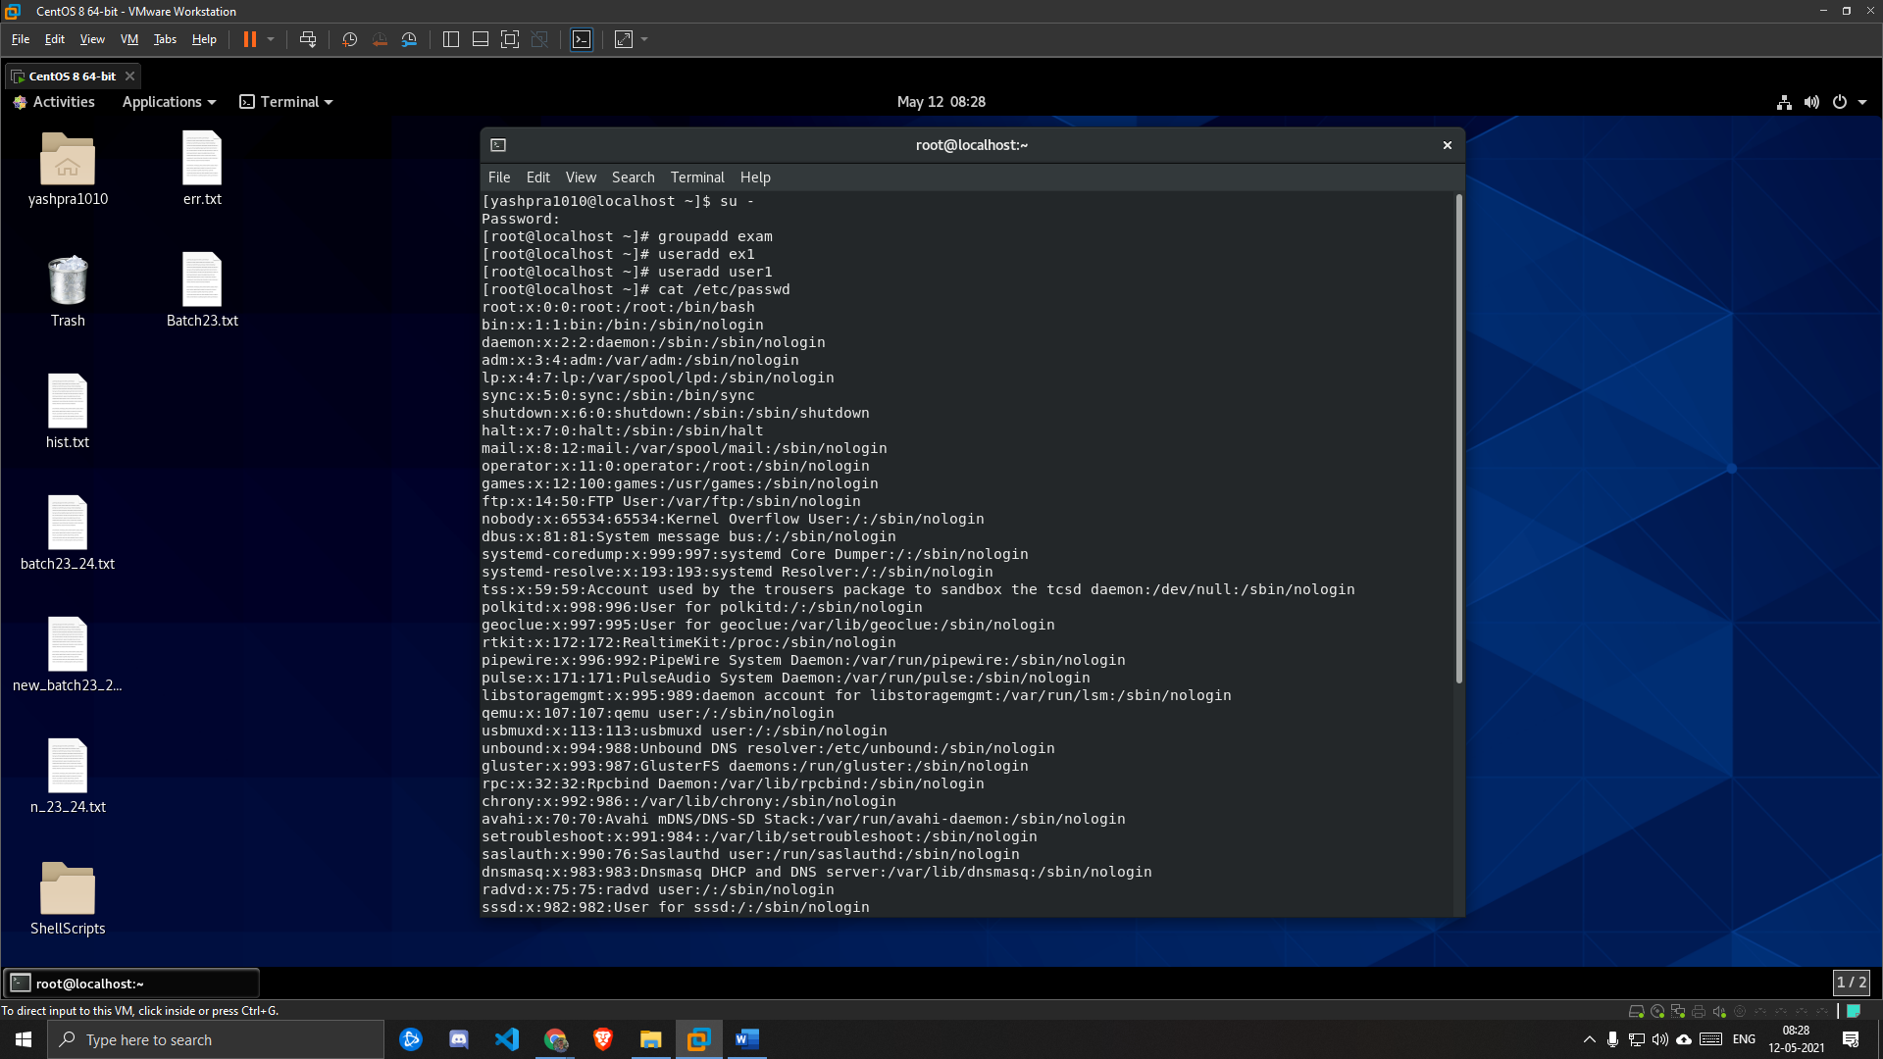

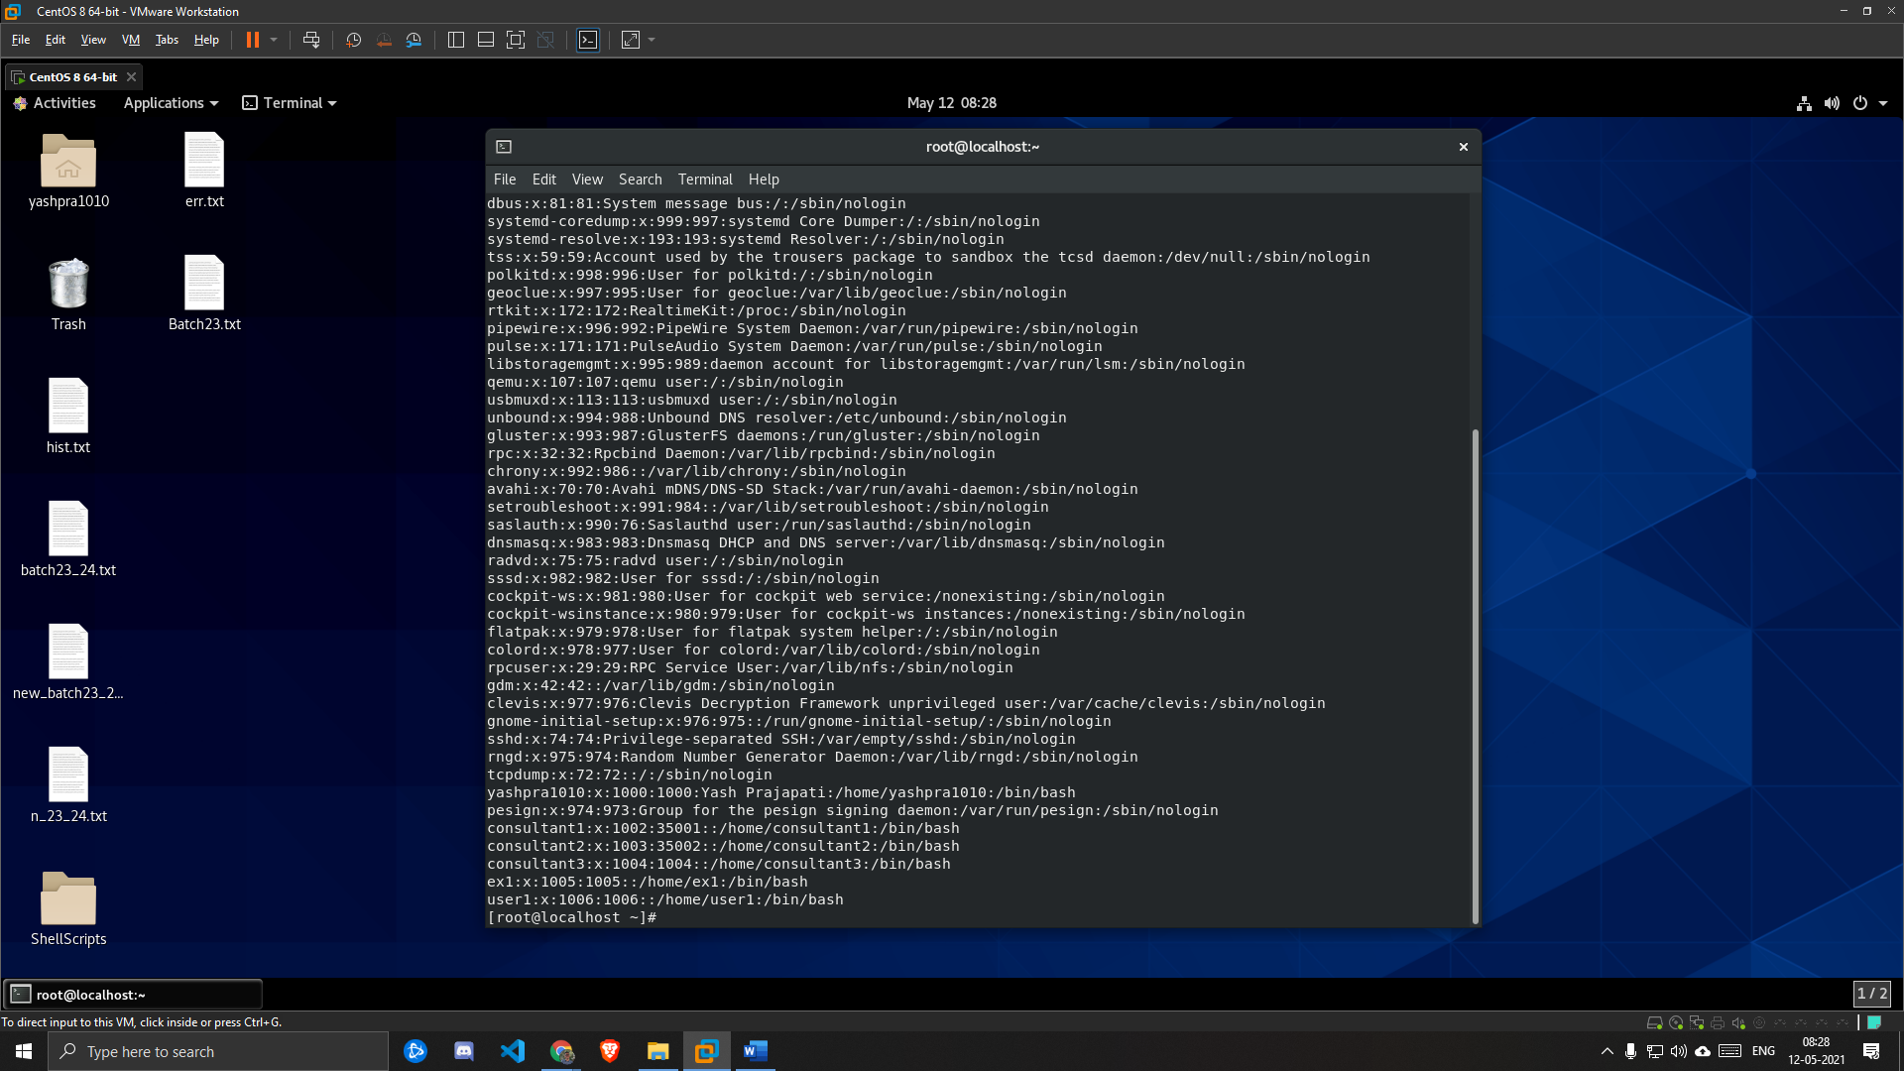

**2. Set password “student123” for both the users. Also set password expiry date after 30 days of password creation for both the users.**

***SOLUTION:***

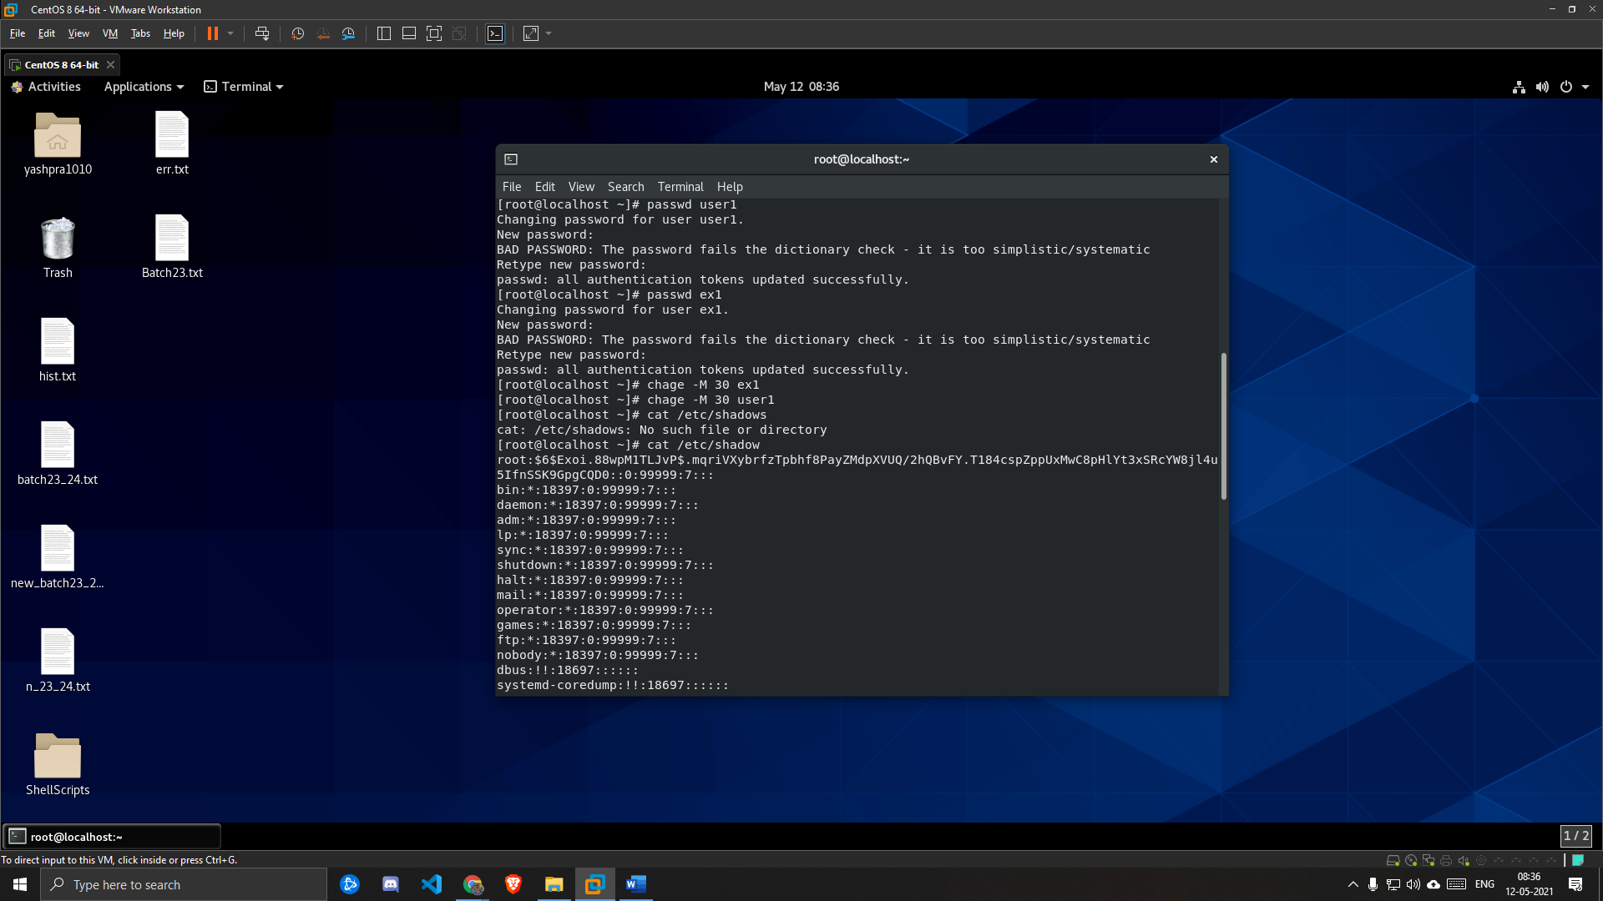

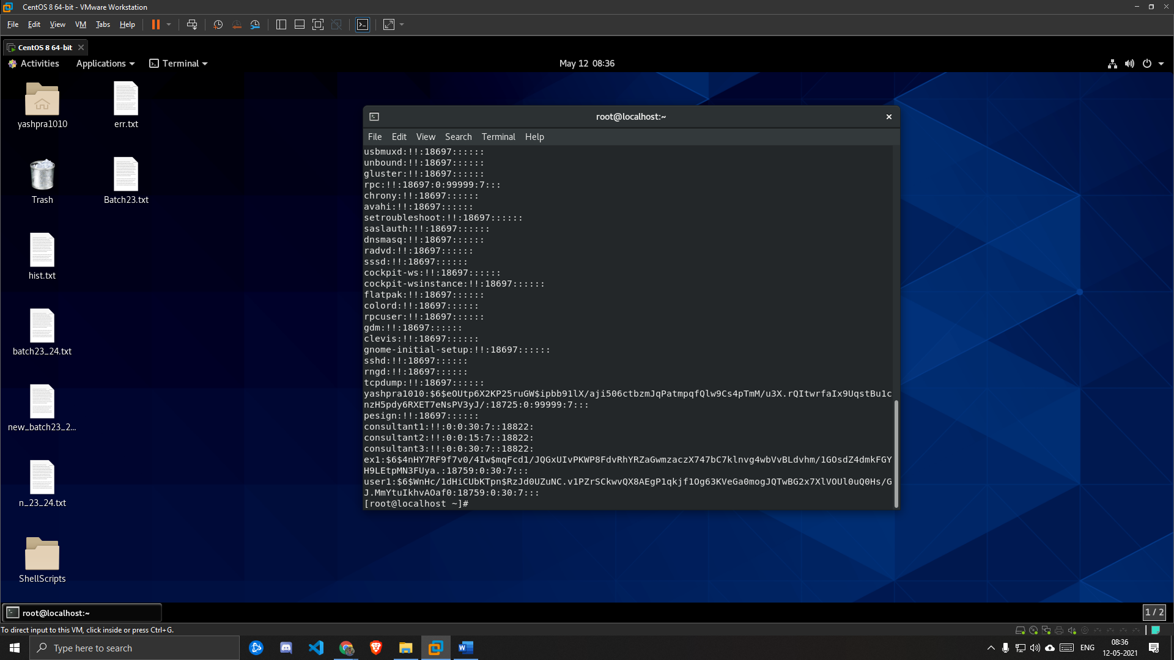

**3. Add exam group as supplementary group for user user1.**

***SOLUTION:***

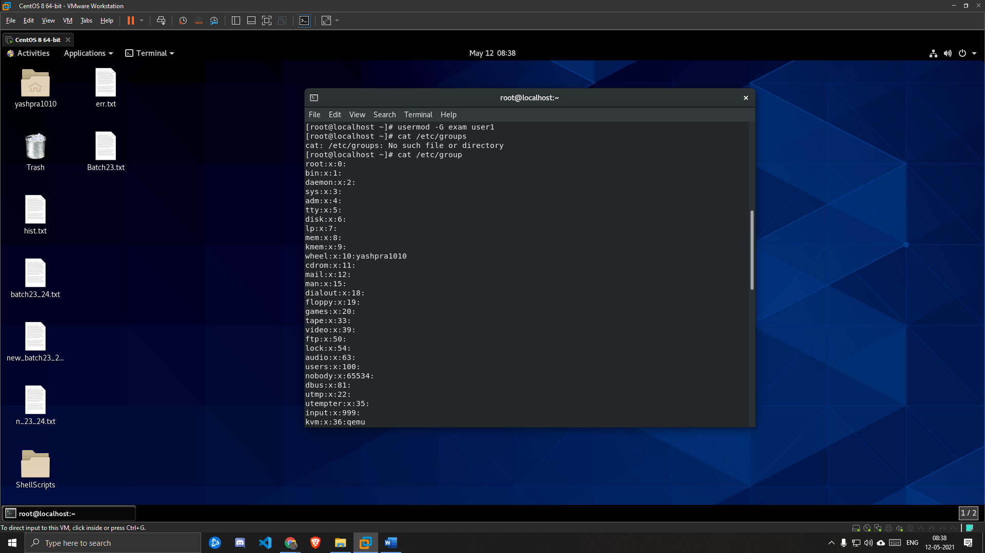

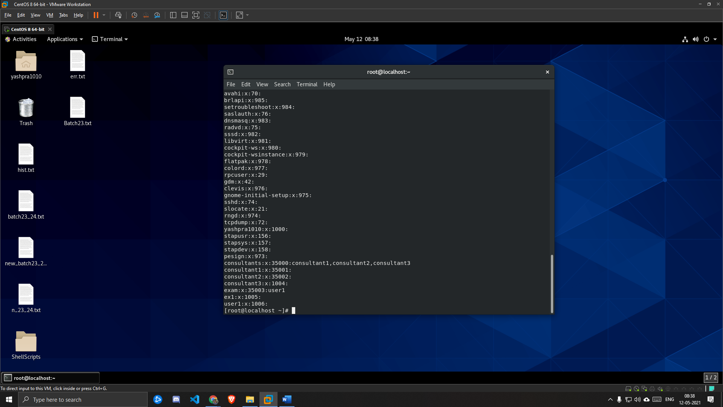

**4. He wants to create a directory called /home/exam.**

***SOLUTION:***

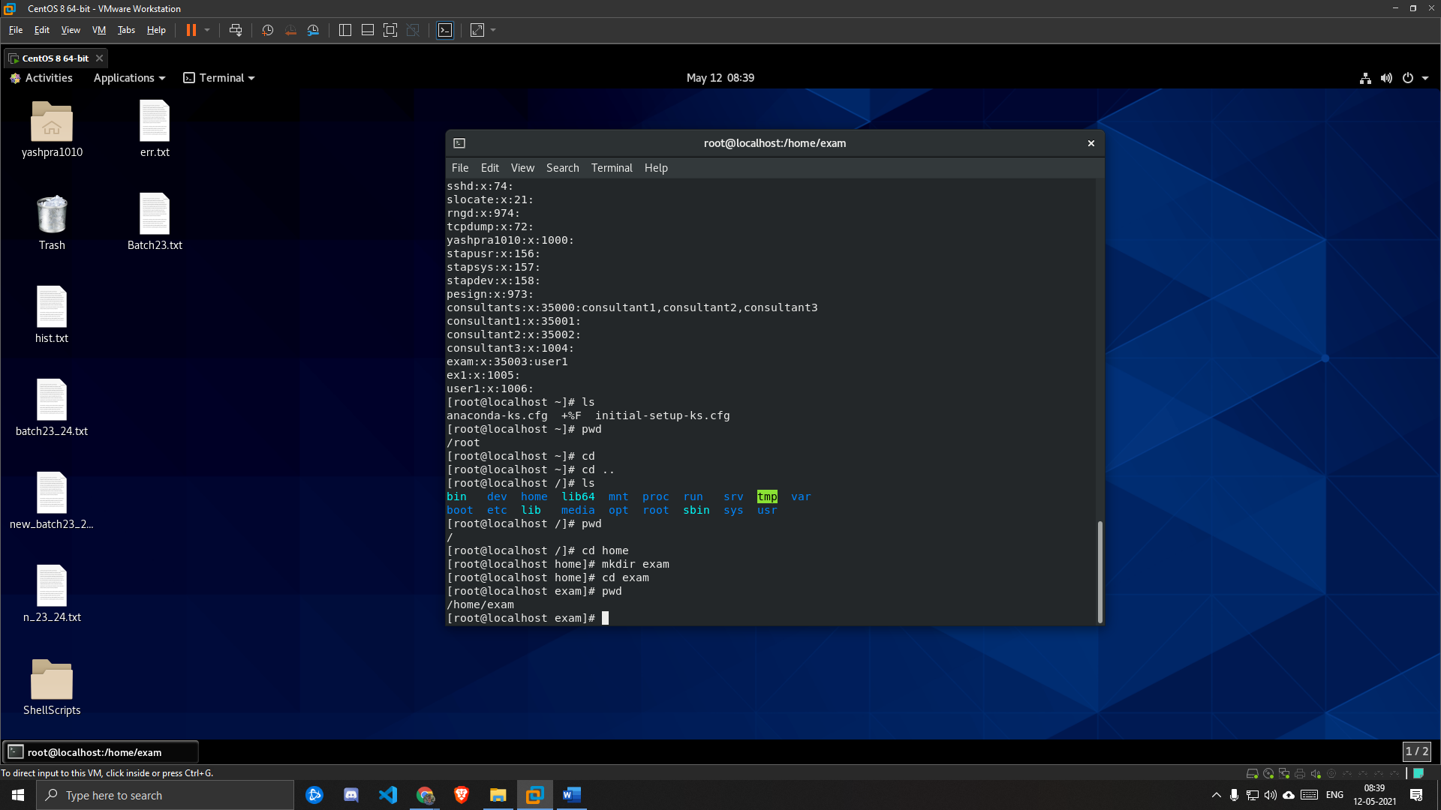

**5. Now, Change the group ownership of the /home/exam directory to the exam group.**

***SOLUTION:***

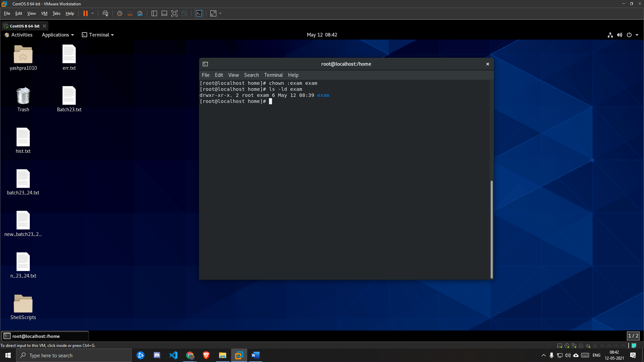

**6. Set permissions on the /home/exam directory. On the /home/exam directory, configure set gid, read+write+execute permissions for the user and group, and read+execute permissions for other users.**

***SOLUTION:***

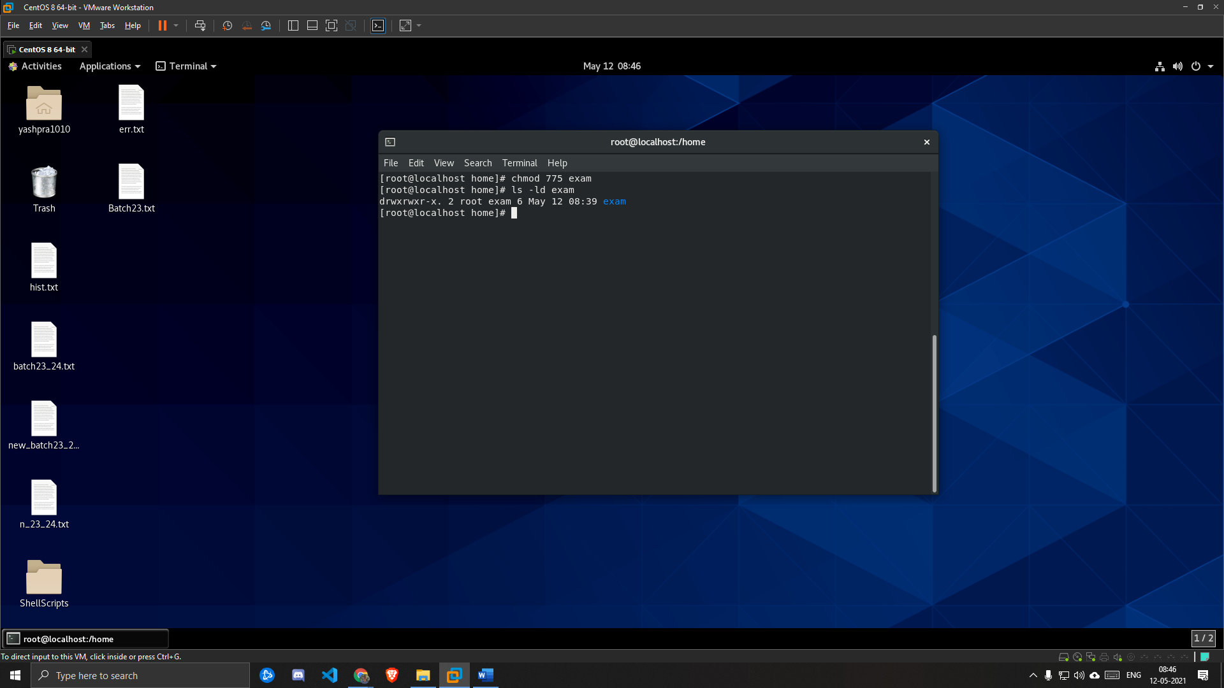

**7. Confirm that users in the exam group can now create and edit files in the /home/exam directory. Users who are not the member of an exam group, they can access the /home/exam directory but cannot edit or create files in the /home/exam directory.**

***SOLUTION:***

